Assignment No 2 Linear Algebra and Analytical Geometry 19SW I / II

Q1. Reduce each of the following matrices into the indicated form Also determine the Rank of the matrix:

echelon form reduced echelon form

**Solution to Qno i & ii:**

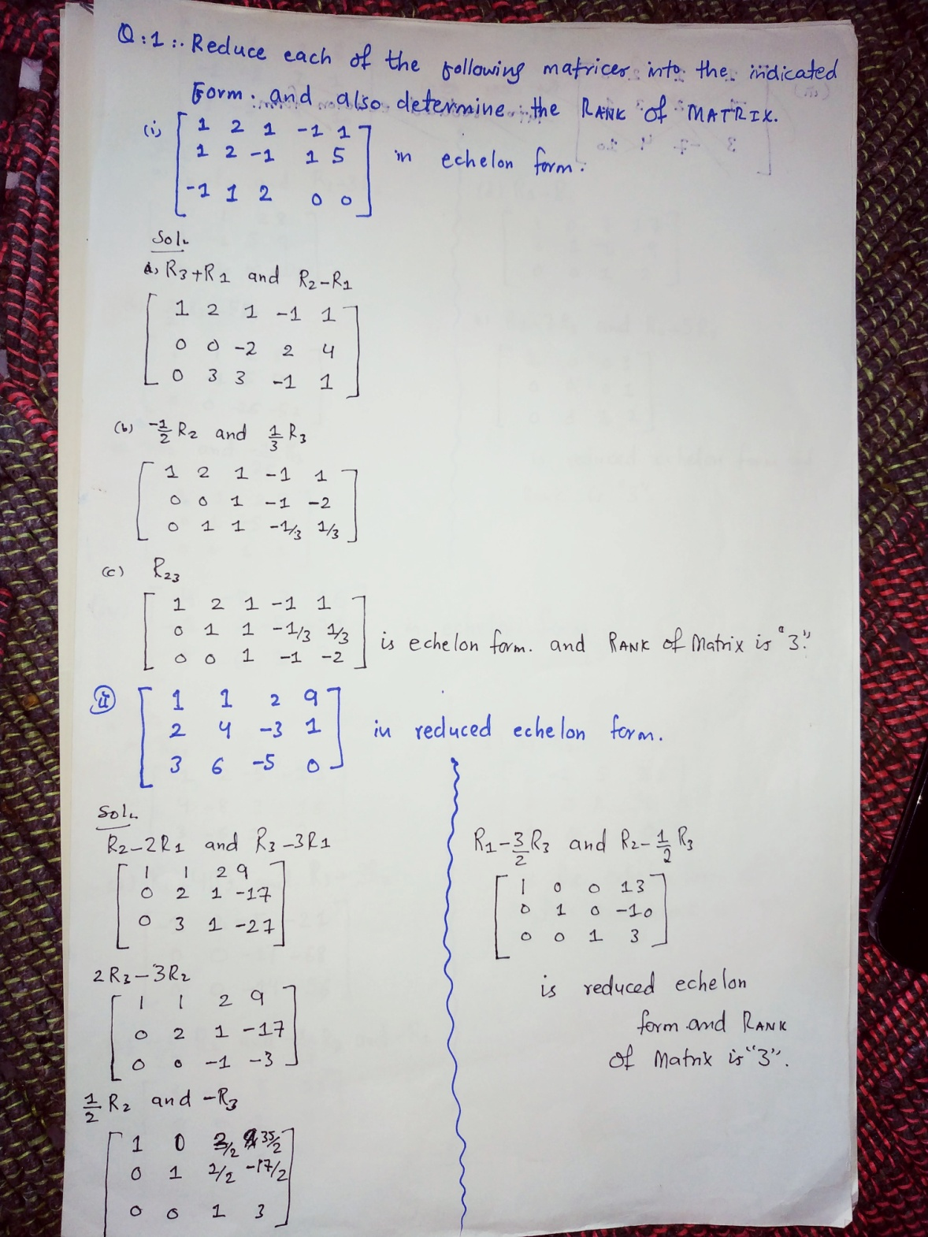

reduced echelon form echelon form

**Solution to Qno iii & iv:**

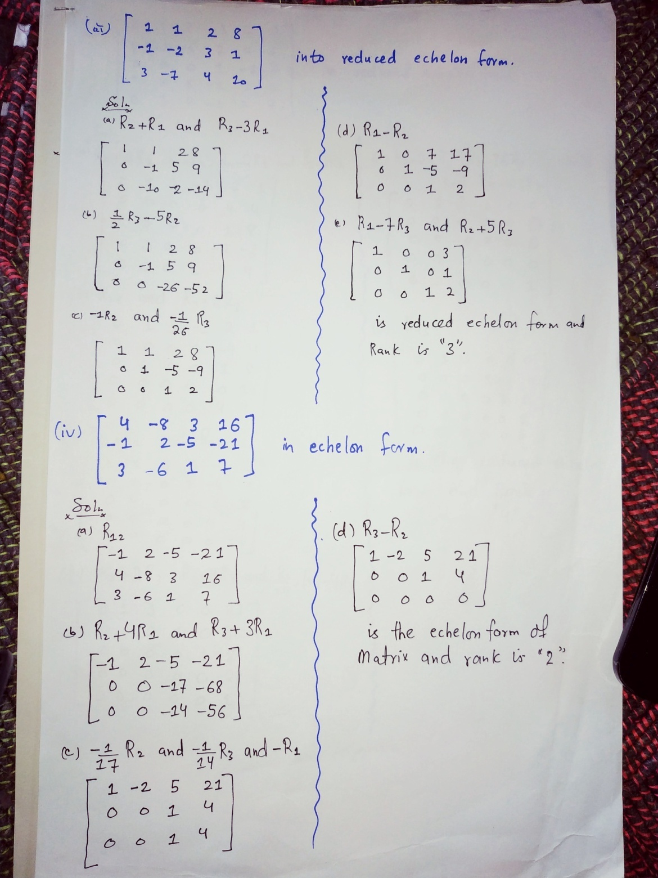

reduced echelon form

**Solution to Qno v:**

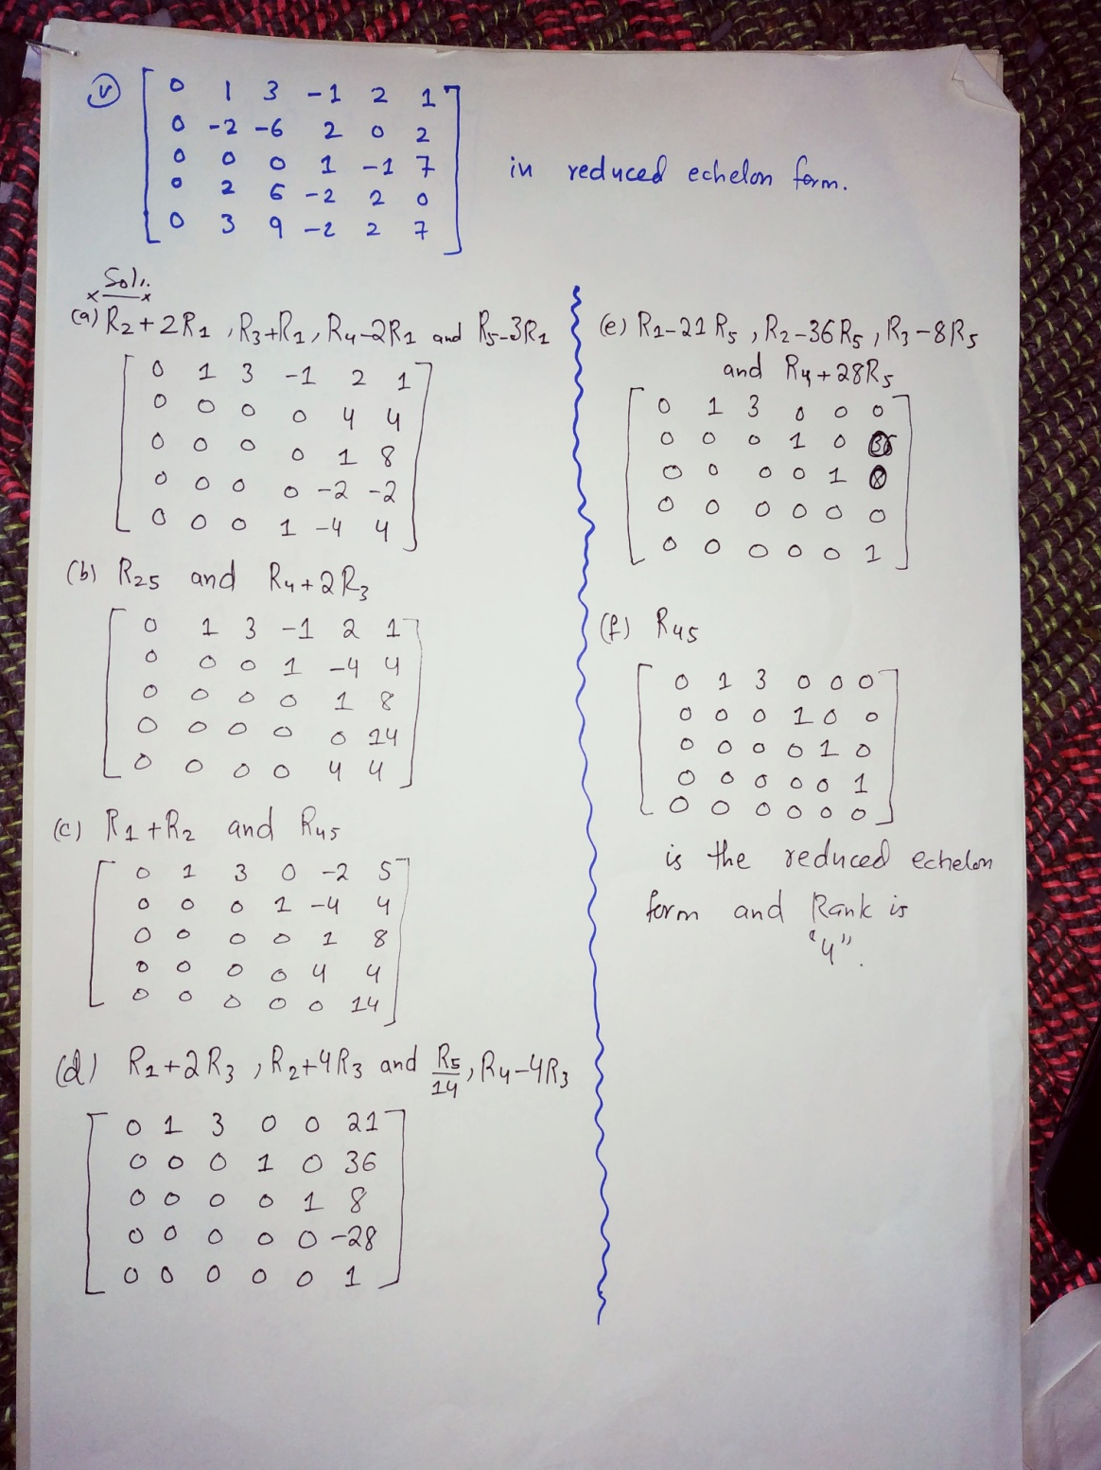

reduced echelon form

**Solution to Qno vi:**

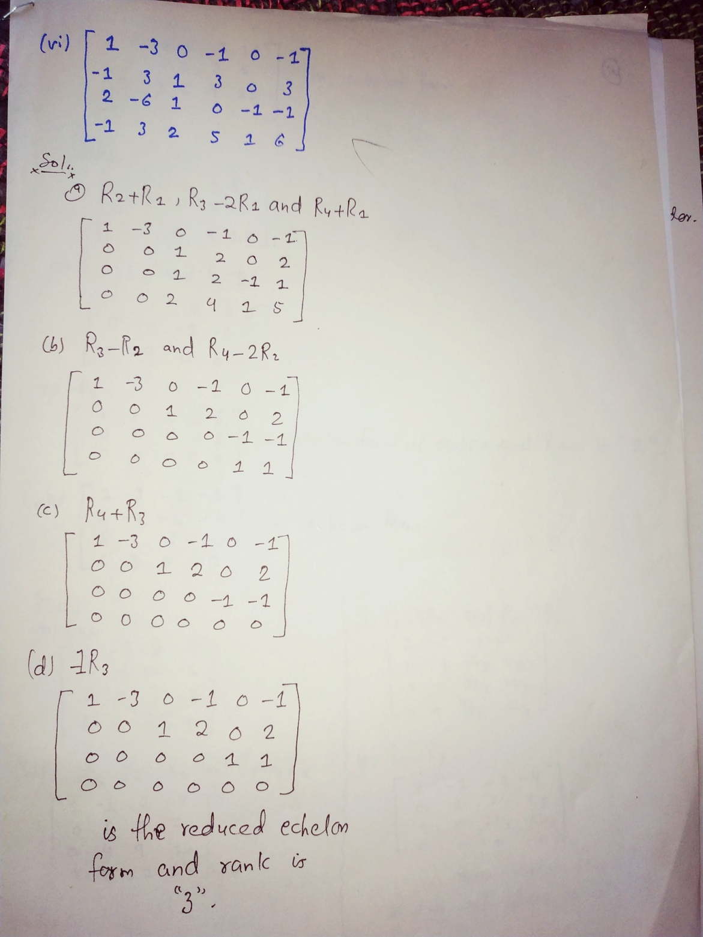

**Solution to Qno vii & viii:**

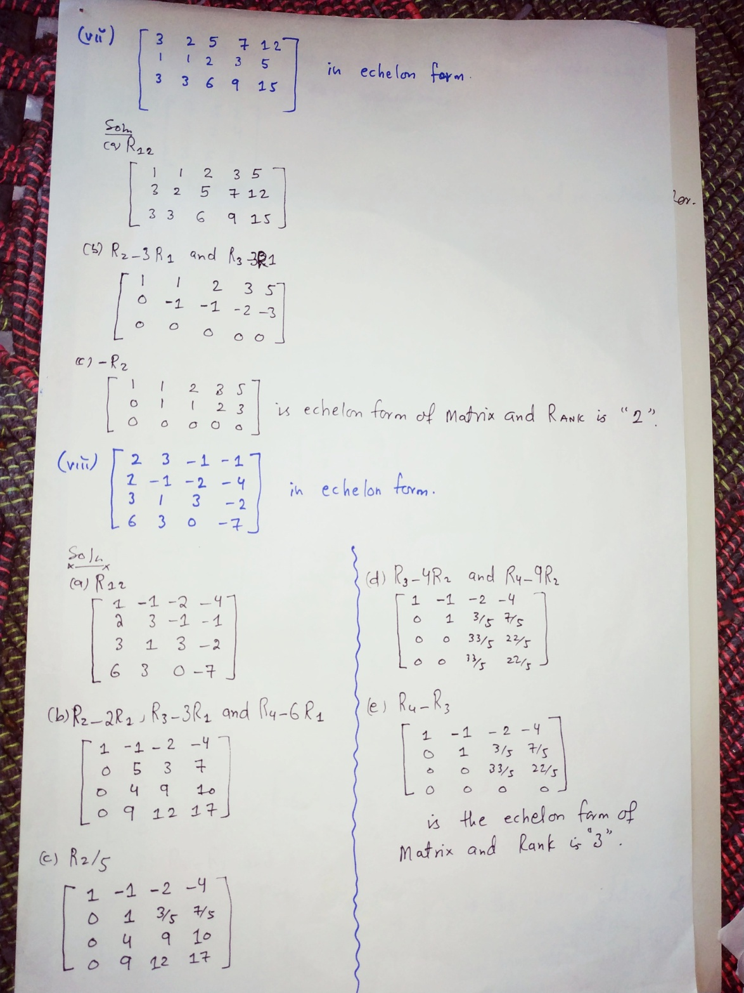

Q2. Find the inverse of the following matrices using elementary row operations:

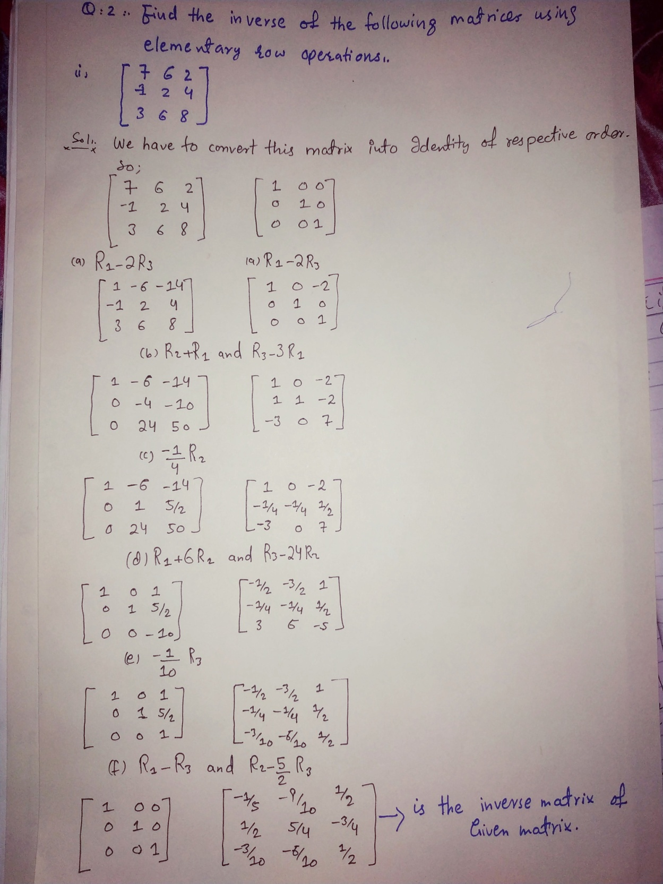

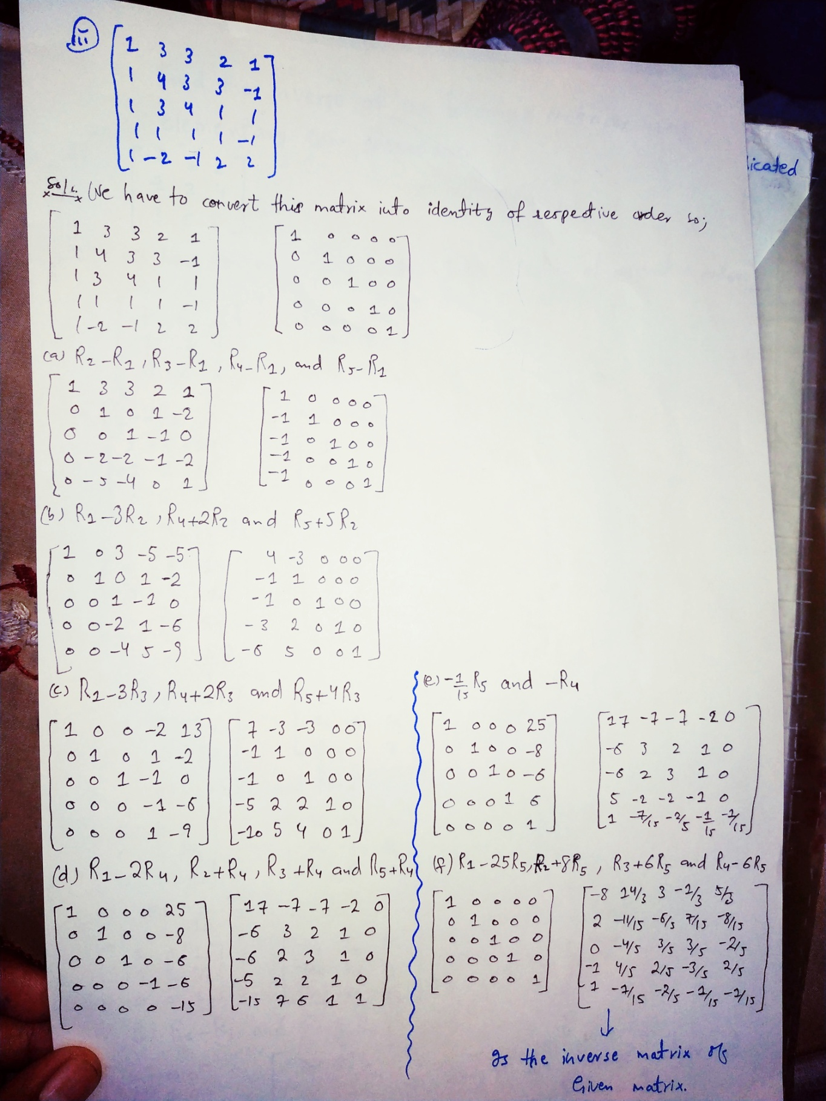

**THE END**